Book

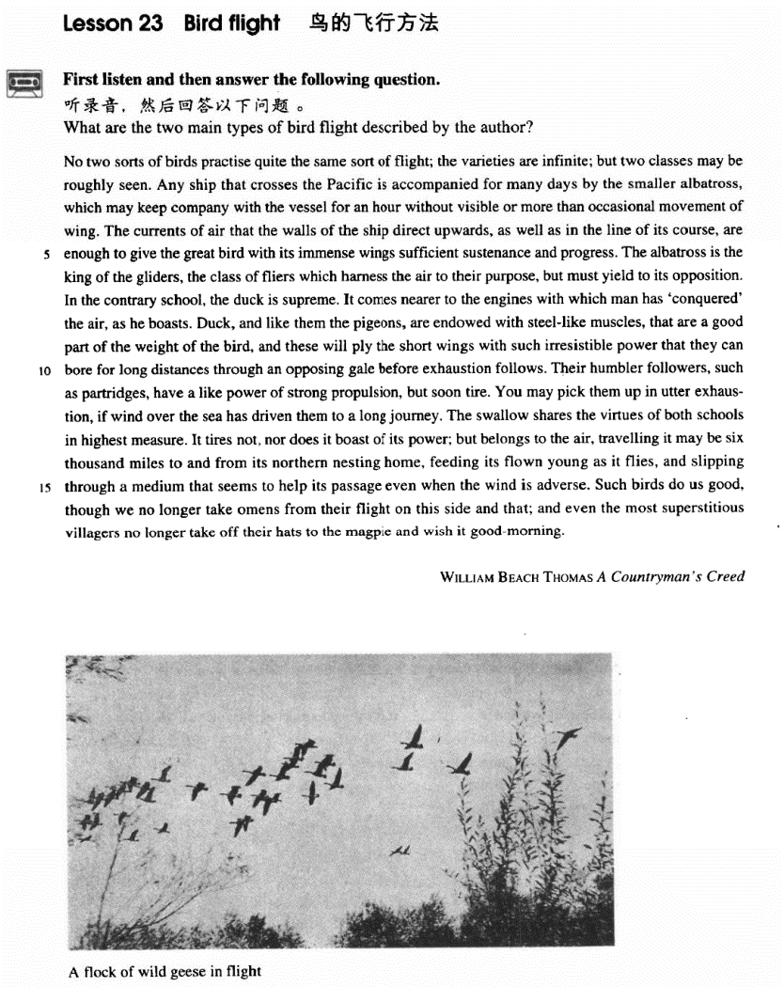

课文

No two sorts of birds practise quite the same sort of flight;

没有任何两种鸟的飞行方式是相同的。

the varieties are infinite; but two classes may be roughly seen.

鸟的飞行方式千差万别，但大体上可分为两类。

Any ship that crosses the Pacific is accompanied for many days by the smaller albatross,

任何一艘横度太平洋的轮船都会有一种小信天翁伴随飞行许多天。

which may keep company with the vessel for an hour without visible or more than occasional movement of wing.

它们随船飞行一小时也难得见其扇动一下翅膀。

The currents of air that the walls of the ship direct upwards, as well as in the line of its course, are enough to give the great bird with its immense wings sufficient sustenance and progress.

沿船体的上升的气流和沿航线向前的气流给这种巨翼大鸟以足够的浮力和推力。

The albatross is the king of the gliders,

信天翁是滑翔飞行的鸟类之王，

the class of fliers which harness the air to their purpose, but must yield to its opposition.

它能自如地驾驭空气，但必须顺气流飞行。

In the contrary school, the duck is supreme.

与滑翔鸟相对的另一类鸟中，数野鸭本领最高。

It comes nearer to the engines with which man has 'conquered' the air, as he boasts.

它更近乎于人类自夸的“征服”了空气的发动机。

Duck, and like them the pigeons, are endowed with steel-like muscles,

野鸭及它们相似的鸽子有天赋的钢铁般的肌肉，

that are a good part of the weight of the bird,

占了体重的很大一部分。

and these will ply the short wings with such irresistible power that they can bore for long distances through an opposing gale before exhaustion follows.

这些肌肉以巨大的力量扇动短小的翅膀，使这类鸟能顶着大风飞行很远的路才会疲劳。

Their humbler followers, such as partridges, have a like power of strong propulsion, but soon tire.

次于野鸭和鸽子的鸟，如鹧鸪，有相似的巨大推动力，但很快会疲劳。

You may pick them up in utter exhaustion, if wind over the sea has driven them to a long journey.

如果海风驱使它们飞行很长距离，你可以捡到一些因筋疲力尽而摔下来的鹧鸪。

The swallow shares the virtues of both schools in highest measure.

燕子充分兼有这两类鸟的长处，

It tires not, nor does it boast of its power; but belongs to the air travelling it may be 6,000 miles to and from its northern nesting home, feeding its flown young as it flies, and slipping through a medium

它既不疲劳，也不炫耀自己的飞翔力；在空中十分自如，可以飞行6，000英里，可以飞往北方做窝的老家，再从老家飞回；一边飞一边喂养会飞的雏燕，甚至在顶风时也能在气流中滑翔，似乎气流在帮它前进。这些鸟对我们是有益的，

that seems to help its passage even when the wind is adverse. Such birds do us good,

虽然我们不再从它们的飞翔姿态来占卜吉凶，

though we no longer take omens from their flight on this side and that; and even the most superstitious villagers no longer take off their hats to the magpie and wish it good-morning.

连最迷信的村民也不再对喜鹊脱帽行礼，祝它早安了。

词汇讲解

Lesson 23 Bird flight

albatross ['ælbətrɒs]

n. 信天翁

albatross n. a large white sea bird the Rime of the Ancient Mariner

《古舟子咏》(《老水手之歌》)

It is a poem written by the English poet Samuel Taylor Coleridge in 1797–1799.

The Ancient Mariner is an old sailor who shoots and kills an albatross . The other sailors think that this will bring them bad luck, and they force him to wear the dead albatross on a rope around his neck so that they will not be punished for his crime.

But all the sailors die, and the Ancient Mariner feels guilty and believes he must tell his story to anyone who will listen, to warn them to be kind to all creatures.

an albatross (around one’s neck)

The scandal is an albatross around the president’s neck. duck pigeon

swallow partridge

lame duck

With 11 months left to go in his second term, George W. Bush looks more and more like a lame duck president.

sitting duck

With their bullets all gone, the soldiers were sitting ducks for the enemy. pigeon

carrier pigeon

pigeon-chested/breasted

pigeon-toed

dove hawk

sustenance ['sʌstənəns]

n. 食物，营养，生计； 持续，维持

sustenance n. 1. nourishment, food 食物，营养，生计

The long hours in the office or the factory bring with them as their reward, not only the means of sustenance, but a keen appetite for pleasure even in its simplest and most modest forms.

sustenance n. 2. 持续下去，维持下去

Elections are essential for the sustenance of democracy. sustain sustainable

sustainable growth sustainable development

sustainable development strategy

In 1950, the U.S. spent $12.7 billion on health care. In 2002, the cost will be $1,540 billion. Anyone can see this trend is unsustainable.

Yet few seem willing to try to reverse it. Some scholars conclude that a government with finite resources should simply stop paying for medical care that sustains life beyond a certain age — say 83 or so.

sustain maintain

retain detain

attain contain

obtain abstain

The branches could hardly the weight of the fruit.

(A) retain (B) sustain

(C) maintain (D) remain harness ['hɑ:nɪs]

n. 马具；v. 利用自然力

harness

There is a great deal of interest in harnessing wind and waves as new sources of power.

table table a proposal / bill

chair

Would you like to chair tomorrow's meeting? implement farming implements implement a plan / policy / UN resolution

gear gear sth. to / towards sth. He geared his speech to a conservative audience.

Ever since the rise of industrialism, education has been towards producing workers.

(A) harnessed (B) hatched

(C) motivated (D) geared endow [ɪn'daʊ]

v. 资助；赋予

endow vt. 1. to give a large amount of money to pay for creating a college or hospital, etc. or to provide an income for it 资助，捐助

Some American colleges are state-supported, others are privately ,

and still others are supported by religious organizations.

(A) ensured (B) attributed

(C) authorized (D) endowed endow sb. with sth.

provide sb. naturally with ...

She is endowed with both beauty and brains. Declaration of Independence

We hold these truths to be self-evident, that all men are created equal, that they are endowed by the Creator with certain unalienable rights, that among these are life, liberty, and the pursuit of happiness.

― Thomas Jefferson

Nature (A) not only gave the Middle Atlantic region fine harbors (B), however (C) endowed it with (D) a first-class system of inland waterways.

invest sb. / sth. with sth.

Being a model invests her with a certain glamour.

The crimes committed there invested the place with an air of mystery and gloom.

If we glimpse the unutterable, it is unwise to try to utter it, nor should we seek to invest with significance that which we cannot grasp.

propulsion [prə'pʌlʃn]

n. 推进力

propel

Under the guidance of their teacher, the pupils are building a model boat

by steam.

(A) towed (B) pressed

(C) tossed (D) propelled

Many types of rock are from volcanoes as solid, fragmentary material.

(A) flung (B) propelled

(C) ejected (D) injected “pel” = 推

propel repel

expel dispel

compel impel

be / feel compelled to do

President Nixon felt compelled to resign. be / feel impelled to do

I feel impelled to point out that you are making a dangerous mistake. adverse ['ædvɜ:s]

adj. 不利的，相反的

adverse effects

adverse weather conditions adverse circumstances

adverse wind adverse criticism

In the catalog to their first exhibition, they actually invited adverse criticism ― but only because what they feared most was indifference.

A man without an education, many of us believe, is an unfortunate victim of adverse circumstances, deprived of one of the greatest twentieth-century opportunities.

adversity

Adversity makes a man.

I played basketball alongside famous players, and the team I now coach, the New York Knicks, has recovered from years of adversity to become a major contender in the 1990s.

adversary ADVISOR：COUNSEL

adversary：vanquish

steward：squander

chaperone：escort

disciple：lead

mediator：dispute omen ['əʊmən]

n. 预兆，征兆

a good omen

an auspicious omen a bad omen

an ill omen

an ominous omen

There has long been a superstition among mariners that porpoises will save drowning men by pushing them to the surface, or protect them from sharks by surrounding them in defensive formation.

No two sorts of birds practise quite the same sort of flight; the varieties are infinite; but two classes may be roughly seen.

No money buys health.

No necessity of making a living away from home results in neglect of children, and no father is confronted with his inability to 'buy' an education for his child.

practise (Am.E. practice)

Nearly all the sports practised nowadays are competitive. practice

On the other hand, your stomach would turn at the idea of frying potatoes in animal fat — the normally accepted practice in many northern countries.

造句：没有任何两个人的指纹是一模一样的。指纹的种类千差万别， 但大体上可以分为两种：斗 (whorl) 和簸箕 (loop)。

No two individuals share quite the same pattern of fingerprints; the varieties are infinite; but two classes may be roughly seen: whorl and loop.

there are ... ways / kinds / sorts / types / categories / classes ...

There are three categories of accommodation: economical, standard and deluxe.

fall into ... categories

Shakespeare’s plays fall into three categories: tragedies such as Hamlet, comedies such as The Merchant of Venice and histories such as Henry Ⅳ.

be divided into ... classes

Broadly speaking, human beings may be divided into three classes: those who are toiled to death, those who are worried to death, and those who are bored to death.

Any ship that crosses the Pacific is accompanied for many days by the smaller albatross, *which may keep company with the vessel for an hour without visible or more than occasional movement of wing*.

accompany

be accompanied by ...

Such inns as there were were generally dirty and flea-ridden; the food simply local cheese accompanied by bread often twelve months old, all washed down with coarse wine.

keep company with ... keep sb. company

I’ll keep you company tonight. She is good company.

I enjoy her company.

I feel nervous in her company.

Gradually the river grows wider, the banks recede, the waters flow more quietly, and in the end, without any visible break, they become merged in the sea, and painlessly lose their individual being.

more than + adj.（加强语气）极其……,非常..……

He is more than selfish.

She can't help the man look for another platter.

She forgot the platter had been broken.

She didn't realize the platter had been broken.

She doesn't want the man to replace the platter.

M: I don’t know how I managed to break that platter. I’ll be *more than*

happy to buy you a new one.

W: Forget about it. Some things just can’t be helped. What does the woman mean?

Answer: (D) She doesn't want the man to replace the platter. more than + n. 超过……，不仅仅是……

Peace is more than the absence of war.

These days, it is differences in national regulations, far more than tariffs, that put sand in the wheels of trade between rich countries.

It is impossible to make more than the wildest guess at how many they kill, ...

I looked into the boy's serious but eager face and asked him, "Do you want any more books?"

"Yes, more than I can ever get," he replied. more than A can / could …

When my old friend Brian urged me to accept a cigarette, it was more than I could bear.

Dancing proved to be more than the dish could bear, for during the party it capsized and sank in seven feet of water.

The story is more than I can believe.

The beauty of the West Lake is more than words can describe.

Such a complicated situation is far more than we could anticipate and deal with.

The currents of air that the walls of the ship direct upwards, *as well as in*

*the line of its course*, are enough to give the great bird with its immense

wings sufficient sustenance and progress. direct vt. aim; point

All the criticism was directed at her.

Any regard for the suffering of animals is seen as a mistake — a sentimental displacement of feeling that should properly be directed to other humans.

造句：全中国人民的共同努力，再加上党的英明领导，足以使这个幅

员辽阔、人口众多、历史悠久的伟大国家持续和发展下去。

The cooperating efforts of all the Chinese people, as well as the wise leadership of the Communist Party, are enough to give the great nation with a vast territory, a big population and a long history sufficient sustenance and progress.

The albatross is the king of the gliders, the class of fliers which harness

the air to their purpose, but must yield to its opposition. be the king of sth.

He is the new king of pop music. be the queen of sth.

She’s the reigning queen of crime writers.

be supreme

In the contrary school, the duck is supreme. The duck is the king of the contrary school. yield to ...

submit to ... bow to ... succumb to …

One January, I had to officiate at two funerals on successive days for two elderly women in my community. Both had died “full of years,” as the Bible would say; both yielded to the normal wearing out of the body after a long and full life.

First, you must give Helen back to my brother. Second, Troy must submit to my command to fight for me whenever I call.

They are constantly after the turtles, who peacefully submit to all sorts of indignities.

the Impressionist school of painting

Let a hundred flowers blossom and a hundred schools of thought contend. The duck is the king of the contrary school.

It comes nearer to the engines with which man has 'conquered' the air, as

he boasts.

It is similar to the engines … man ➔ he

mankind / the human race ➔ it Man has his problems.

Mankind / The human race has its problems.

Although mankind has undergone no general improvement in intelligence or morality, it has made extraordinary progress in the accumulation of knowledge.

If, as has been reported, they have protected humans from sharks, it may have been because curiosity attracted them and because the scent of a possible meal attracted the sharks.

Things can go wrong on a big scale, as a number of people recently discovered in Parramatta, a suburb of Sydney.

boast of / about ... boast that ...

Often a valley boasted no inn at all, ...

Duck, *and like them the pigeons*, are endowed with steel-like muscles, that are a good part of the weight of the bird, and these will *ply* the short wings *with such* irresistible power *that they can bore for long distances through an opposing gale before exhaustion follows*.

steel-like muscles

cat-like animals crystal-like eyes an angel-like girl dream-like music

He earns good money.

We’ve walked a good distance today.

Modern alpinists try to climb mountains by a route which will give them good sport, and the more difficult it is, the more highly it is regarded.

ply sb. with sth.

给某人源源不断地提供…… 夸张 hyperbole

白发三千丈，缘愁似个长危楼高百尺，手可摘星辰

燕山雪花大如席，片片吹落轩辕台

It was rather like an exhibition of prehistoric electronic equipment. a chance in a million

His anger nearly burst his belly. Everybody was clapping their hands off. She cried her eyes out.

He has a skeleton of a wife.

The car cost him an arm and a leg.

Linda didn't like it.

Bill lost it.

It was very expensive.

It was very small.

M: Did you see the diamond ring Bill gave to Linda? W: I sure did. It must have cost him an arm and a leg. Q: What does the woman imply about the ring?

Answer: (C) It was very expensive.

For she was beautiful — her beauty made the bright world dim, and everything beside seemed like the fleeting image of a shade.

— P. B. Shelley ‘The Witch of Atlas’

*opposing / adverse / unfavorable* gale / wind

*favorable* gale / wind

I shaved before I went to the party.

It will be a long time before we meet again.

Looking at his watch, he saw that it was one o'clock, but the bell struck thirteen times before it stopped.

I hadn’t waited long before he came.

造句：马克思主义的信念源源不断地给与红军巨大的动力，他们翻雪山、过草地，跋涉两万五千里，直到到达了长征的终点——吴起镇。Marxist convictions plied the Red Army with such irresistible power that

they trekked for 25,000 li over snow-capped mountains and grassy swamps before they reached the town of Wuqi, destination of the Long March.

like adj. 前置定语

alike adj. 表语

similar

likely adj. probable

Some (A) antibiotics used in (B) the treatment of human disease are like

(C) only in that they are obtained (D) from fungi and bacteria.

Anyone who has spent time with children is aware of the difference in the way boys and girls respond to situations.

[A] similar [B] alike

[C] same [D] likely

If we glimpse the unutterable, it is unwise to try to utter it, nor should we seek to invest with significance that which we cannot grasp.

That’s utter nonsense.

He looked at me in utter disbelief. She gazed at me in utter confusion. We share an interest in botany.

I believe my view is widely shared.

Not everyone will share your enthusiasm for the plan.

That all great art has this power of suggesting a world beyond is undeniable. In some moods, Nature shares it.

... that running, jumping and kicking a ball are tests of national virtue. in highest measure = to the highest degree

in great / large measure in some measure

The true value of a human being is determined primarily by the measure and the sense in which he has attained liberation from the self.

— Albert Einstein

It tires not, nor does it boast of its power; but belongs to the air, travelling *it may be* six thousand miles to and from its northern nesting home, feeding its flown young as it flies, and slipping through a medium *that seems to help its passage even when the wind is adverse.*

It tires not.

= It doesn’t tire.

She loves me not.

= She doesn’t love me.

And so, my fellow Americans, ask not what your country can do for you; ask what you can do for your country.

— John F. Kennedy

Spiders are not insects, as many people think, nor even nearly related to them.

boast of / about ...

nesting home=home for nesting the mother fox and her young

He slipped on a piece of ice and broke his left leg. I’ll slip the letter under your door.

She slipped her arm through mine. slip on the shoes

slippers

slip through the net

He slipped quietly out of the room.

His popularity slipped further after a series of scandals. medium → media

datum → data stratum → strata bacterium → bacteria

curriculum → curricula

the passage of time

Such birds do us good, though we no longer take omens from their flight on this side and that, and even the most superstitious villagers no longer take off their hats to the magpie and wish it good-morning.

do sb. good = benefit sb.

I think a trip to the beach would do us all a lot of good. do sb. harm

The occasional piece of candy doesn’t do you any harm. do more harm than good

Raising speed limits may do more harm than good.

We have been brought up to fear insects. We regard them as unnecessary creatures that do more harm than good.

take omens from ... take omens from cards

take sth. as omens for ...

She took all the little things that happened that day as omens for their future married life.

superstitious superstition foster superstition

break down / abolish superstition wish sb. sth.

I wish you great success.

I wish you a splendid future. may sb. do

May God bless you.

May you have a splendid future.